Toll Calculator Use cases Verification-

John decided to enjoy the time with his family. He was exploring options and later decided to move to his hometown. It has been long since he visited his ancestral place. The desired location is unfortunately far away and in between multiple toll booths exists.

There is a newly developed toll booth installed some days back and it is costing the rider but at the same time helping the government in revenue generation.

Good Point about the booth is that they put the upper restriction on the amount charged per day.

Frequent travelers’ moving several times in a day is charged a max amount of 60.

Travelling within same hour multiple times will cost him the amount maximum within that hour.

John started on weekend 5th January 2013 – 2013-01-05T13:31:22 (Saturday)

Request Object-

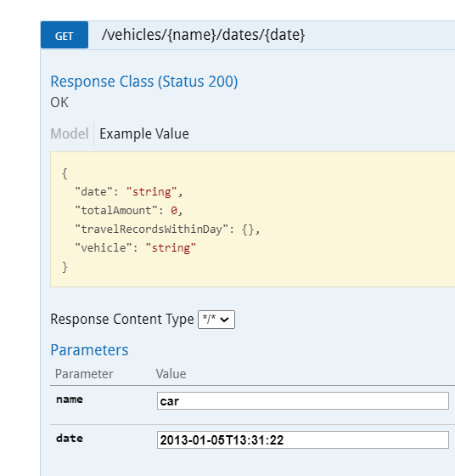

Response Object-

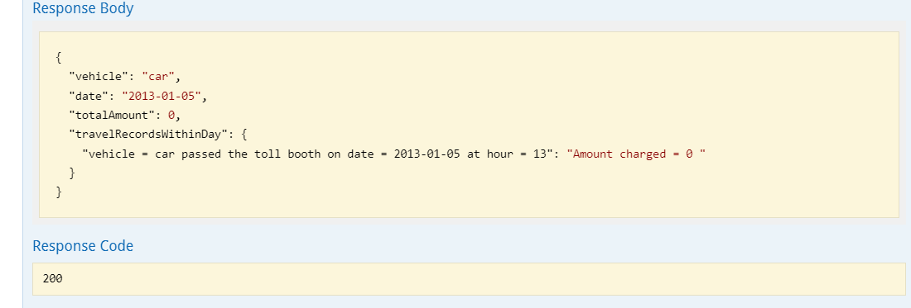

John become very happy as he was charged nil.

Motivated John then tried immediately next day 6th January 2013 – 2013-01-06T13:31:22 (Sunday)

And again, he was charged nil.

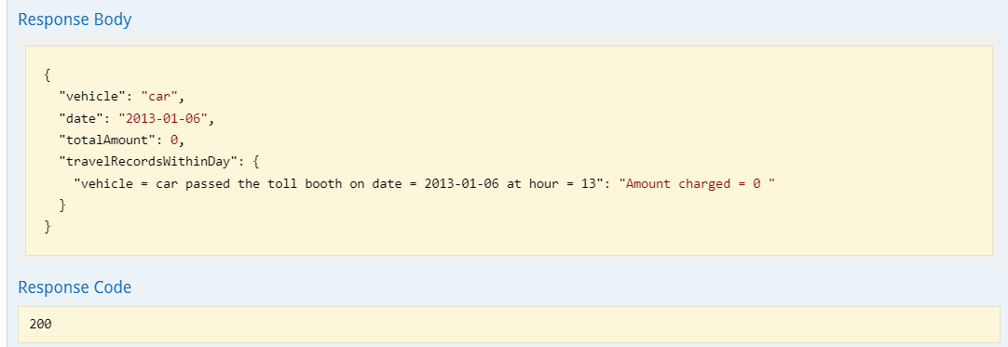

John assumes toll booth is not working properly and want to tap the fault and then he tried the next day-Monday – 2013-01-07T04:31:22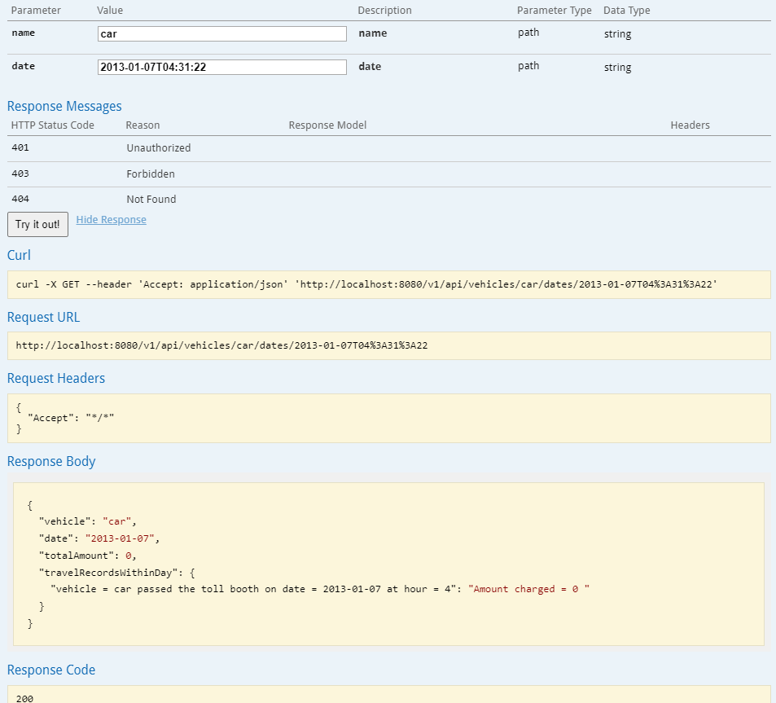

John then drives in next hour same day-

Monday – 2013-01-07T05:31:22

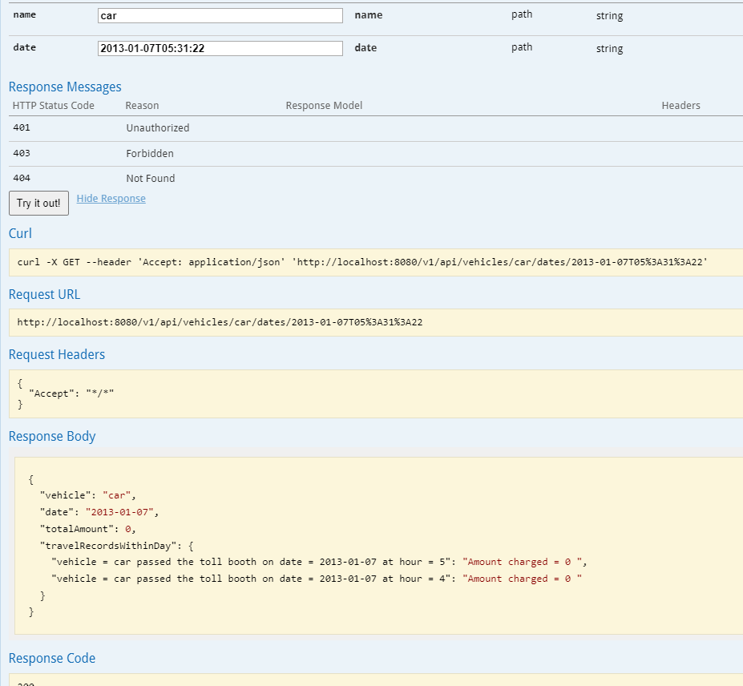

John becomes overconfident and decided today he will visit all his friends as the toll charge is nil.

He attempted next hour-

Monday – 2013-01-07T06:31:22

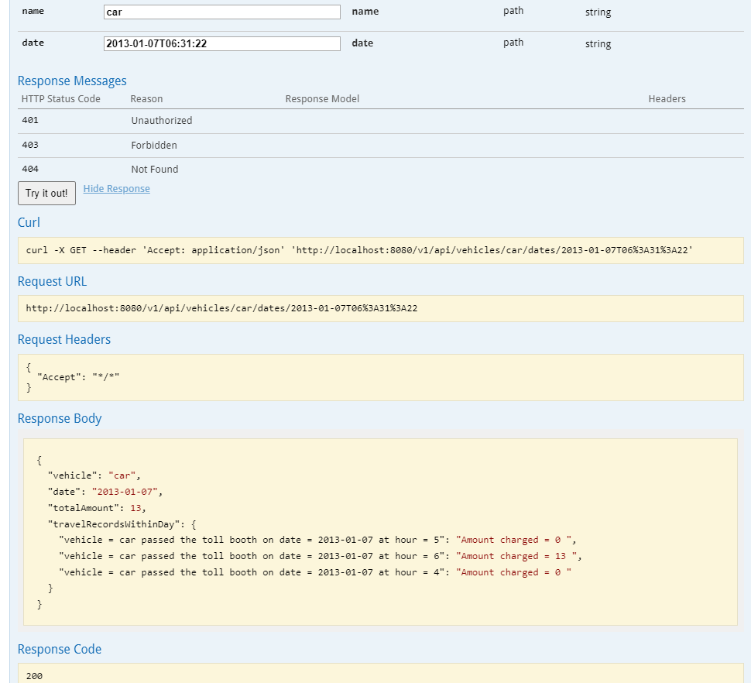

John realized some one told him days back travelling within an hour multiple times can reduce the toll-

He attempted 10 mins back as has a time machine.

Monday – 2013-01-07T06:21:22

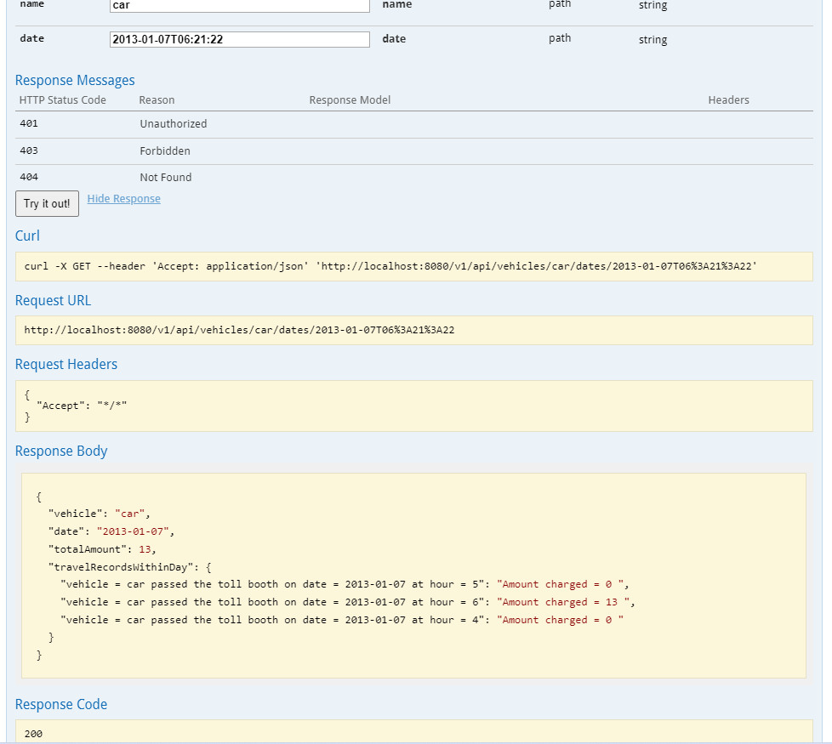

No luck-

But John reason out –

Conclusion 1. One time toll charge in case moving multiple times within an hour and that will be max of them.

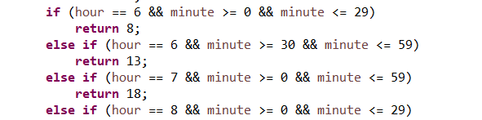

John then tried multiple drives at-

Monday – 2013-01-07T07:21:22

Monday – 2013-01-07T08:21:22

Monday – 2013-01-07T08:31:22

Monday – 2013-01-07T09:31:22

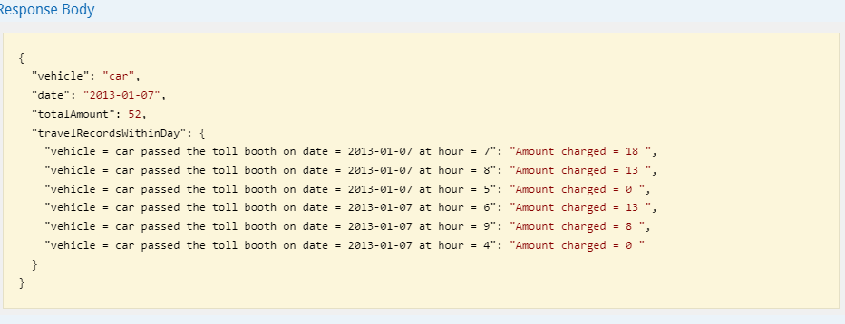

Furious John realizes that the toll was not malfunctioned and indeed following some rules which he was not aware-

Monday – 2013-01-07T10:31:22

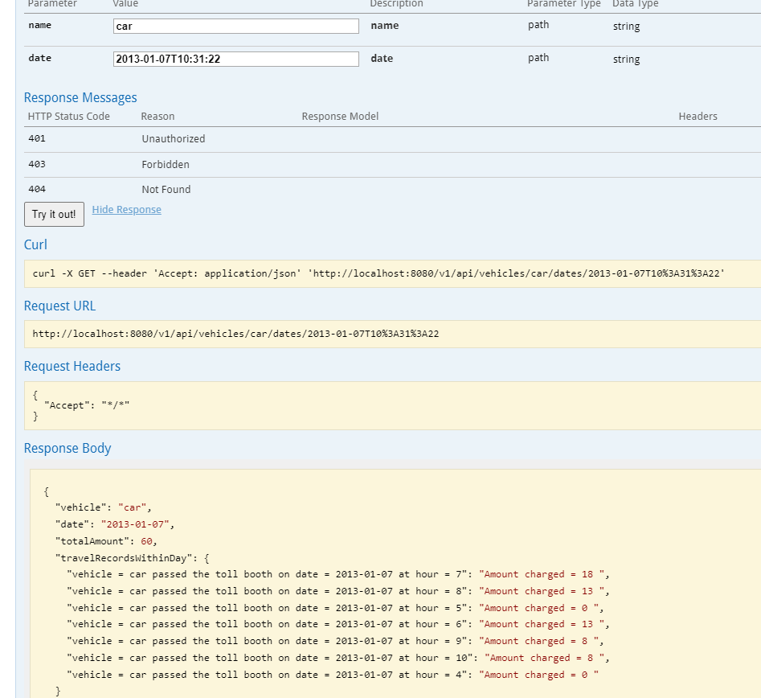

Now the toll touches 60 –

John paused and then checked his pocket.

He has some 100 cents fine he decides to put forward some more drives-

Monday – 2013-01-07T11:31:22

Monday – 2013-01-07T12:31:22

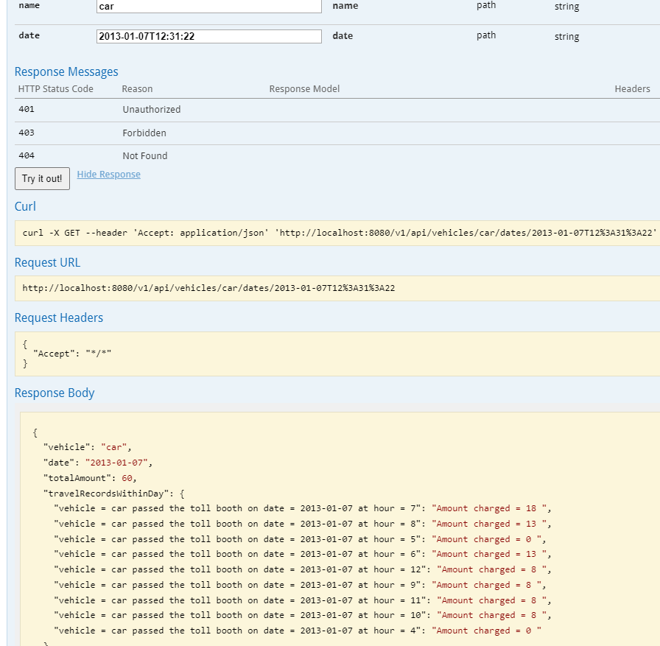

John realized something abnormal as his toll is not going beyond 60. He tried some more times and then reason out the mechanics behind it-

Conclusion 2-

Each day toll can’t go beyond 60.

John finally stopped and went for sleep and then tried on next day-

Tuesday – 2013-01-08T15:21:22

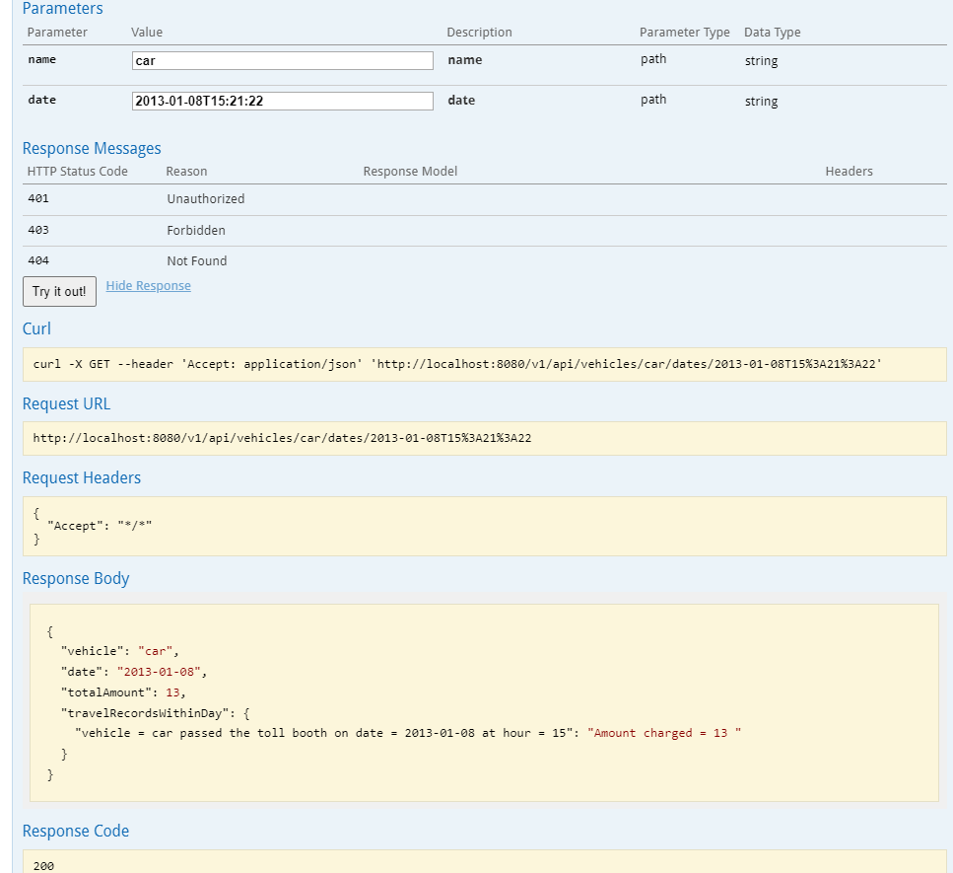

10 minutes later he attempted-

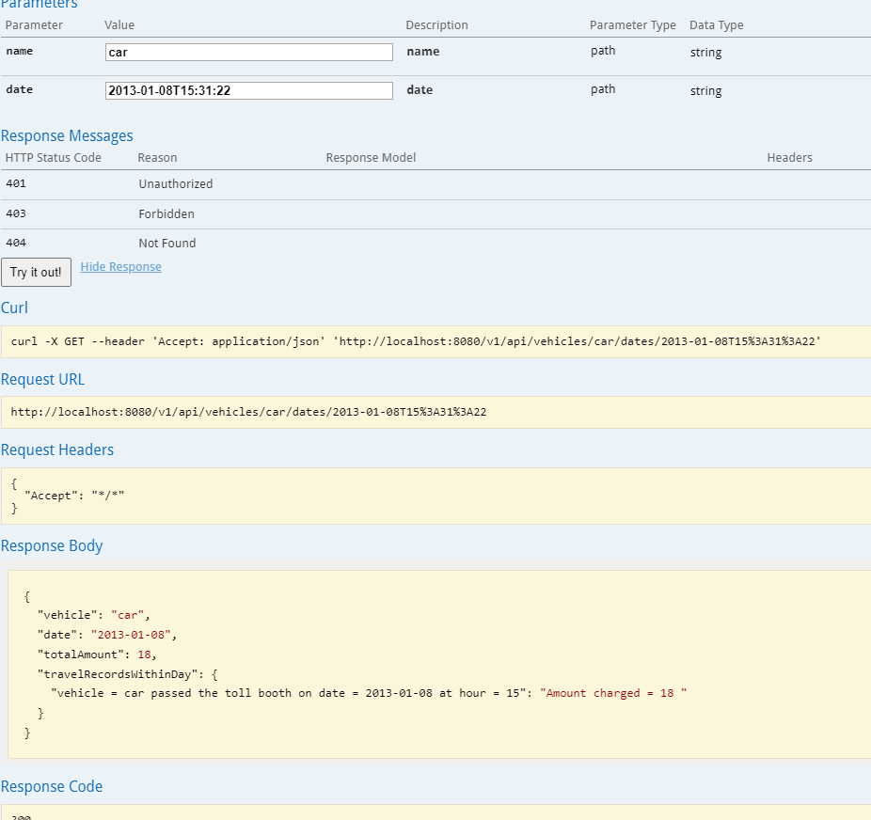

John then went to the toll Booth office and get the historical records of his travelling-

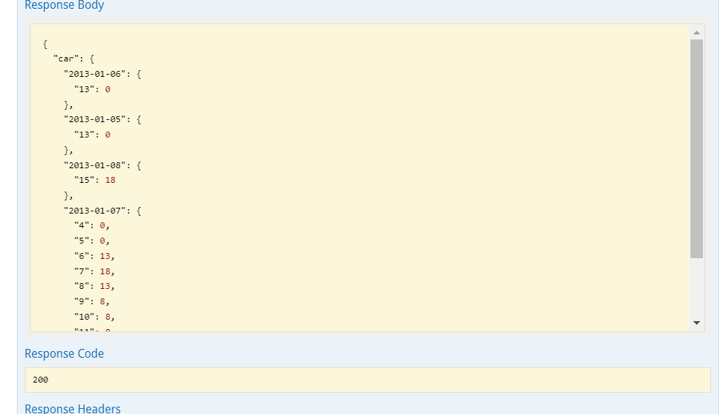

John then happily paid the amount to the toll officer and left.

He summarizes the rules to ever friend of him and make them aware.

* Fees will differ between 8 SEK and 18 SEK, depending on the time of day
* Rush-hour traffic will render the highest fee
* The maximum fee for one day is 60 SEK
* A vehicle should only be charged once an hour
  + In the case of multiple fees in the same hour period, the highest one applies.
* Some vehicle types are fee-free
* Weekends and holidays are fee-free

One correction fees will differ between 0 and 18.